**Map and instructions**

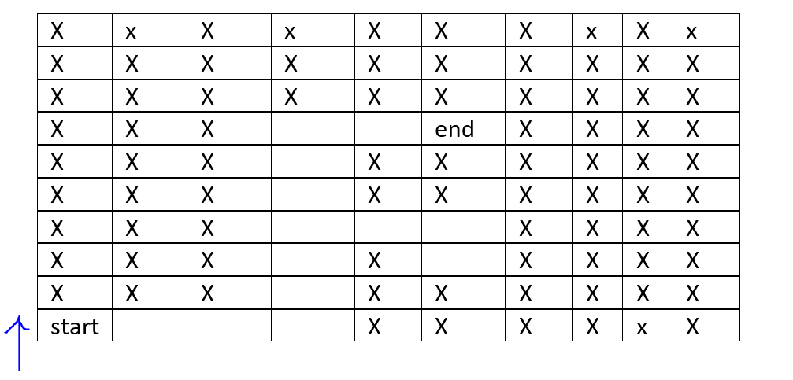

Blue arrow shows the face of the robot. The “X” in the figure 1 shows the blockage. The robot cannot move to “x” marks while the empty cells show the available path for robot. “Start” is the starting position of the robot while “end” is the final goal of the robot. One user’s command can move the robot from one cell to another.

Robot can take following commands only:

For moving forward: “forward” or “Forward”

For moving right: “right” or “Right”

For moving left: “left” or “Left”

For moving back: “back” or “Back”